HD 7449

HD 7449A is a 1.05 M☉, F8 V star1. The CH survey reported a GP (HD 7449Ab) with a period of 1275 days, a minimum mass of 1.11 MJup and an eccentricity of 0.82 as well as a LPGP (HD 7449Ac) with a period of 4046 days, a minimum mass of 2 MJup and an eccentricity of 0.53. Based on 117 RV HARPS measurements obtained between 2003 and 2016, a study performed in 2019 (hereafter W19)2 reported properties close to those of the CH survey for HD 7449Ab and a period of 15441 ± 1059 days (*a* = 12.7 ± 0.6 au), a minimum mass of 19.2 ± 4.2 MJup for HD 7449Ac; its eccentricity was fixed to 0. Independently, high-resolution images obtained with MagAO3 (resp. SPHERE4) in 2014 (resp. 2015), detected HD 7449Ac at a projected separation of 21.1 (resp. 9.62) au, and showed that it is in fact a low-mass star with a mass close to 0.2 M☉.

The approach adopted in the present study was applied as if the direct imaging results were not available, for homogeneity purposes. The data includes the same HARPS dataset as the one used in the W19 study, and, in addition, 12 RV MIKE measurements obtained between 2002 and 2009, 15 RV PFS measurements obtained between 2010 and 2015 and 10 RV CORALIE measurements obtained between 1999 and 2013. DPASS and MCMC (1000 walkers, 500000 iterations) were used to fit the data. In each case, the orbital parameters of HD 7449Ab are very close to those of the W19 study and a minimum mass of 0.82 (resp. 0.84 ± 0.07) MJup was found with DPASS (resp. MCMC). For HD 7449Ac, a period of 7845 days, a minimum mass of 6.4 MJup and an eccentricity of 0.23 were found with DPASS and a period between 19500 and 39700 days, a minimum mass between 35 and 189 MJup were found using MCMC and an eccentricity less than 0.36.

As the RV curve of HD 7449Ac only covers a minimum, the stellar jitter is actually not well constrained. To explore the range of possible values, as done in the present analysis, the stellar offset was fixed to different values and the data, once corrected for the instrumental offsets for clarity purposes, were fitted with DPASS. Stellar offset up to 600 m/s do not significantly change the rms of the residuals (5.8 m/s against 5.0 m/s with offset left free). In this case (referred to as constrained offset), the semi-major axis is 25 au, the minimum mass is 118 MJup and the eccentricity is 0.19. Such values appear to be much closer to the ones deduced from direct imaging data. This example validates our approach. The fits are shown in Fig 1, and the corner plot in Fig 2, and the results summarized in Table 1.

Note that, recently, combining RV, HCI, and Hipparcos/Gaia absolute astrometry data, a study performed in 20225 reported orbital parameters close to those of the CH survey for HD 7449Ab and were able to estimate the orbital inclination of the planet at °, and thus a true mass of MJup. For HD 7449Ac, they found a period of days, an eccentricity of , an inclination of °, and a mass of MJup.

Conclusion: The properties found in the CH survey for HD 7449Ac are not confirmed and high-resolution images showed that it is in fact a low-mass star.

Figure 1: Left: fit of the HD 7449A RV with DPASS. Red - H03, green - H15, blue - MIKE, cyan - PFS, purple - C98, yellow - C07. The blue curve shows the best fit. Middle: fit of the HD 7449A RV with DPASS, with a subtracted stellar offset fixed to 600 m/s. Black points correspond to the data corrected for the instrumental offsets. The blue curve shows the best fit. Right: fit of the HD 7449A RV using MCMC. The black curve shows the best fit. The gray dotted line indicates the end of the CH survey.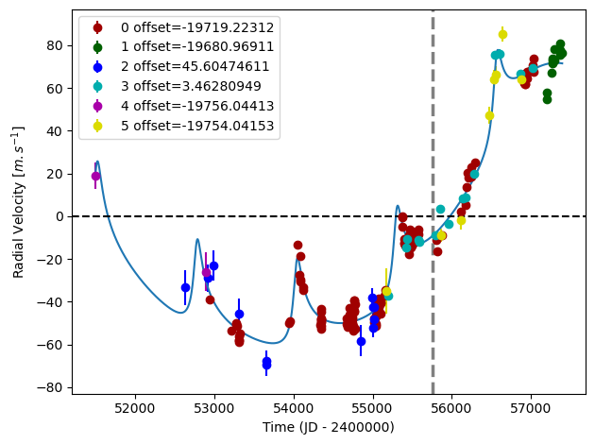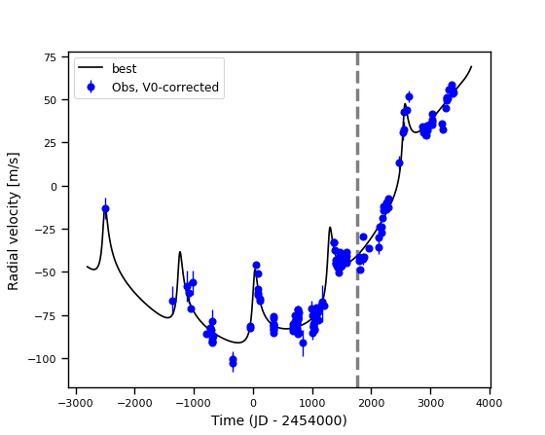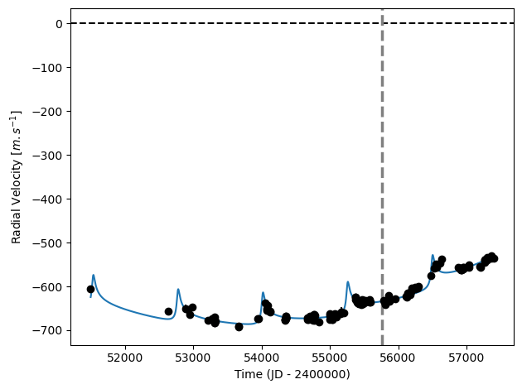

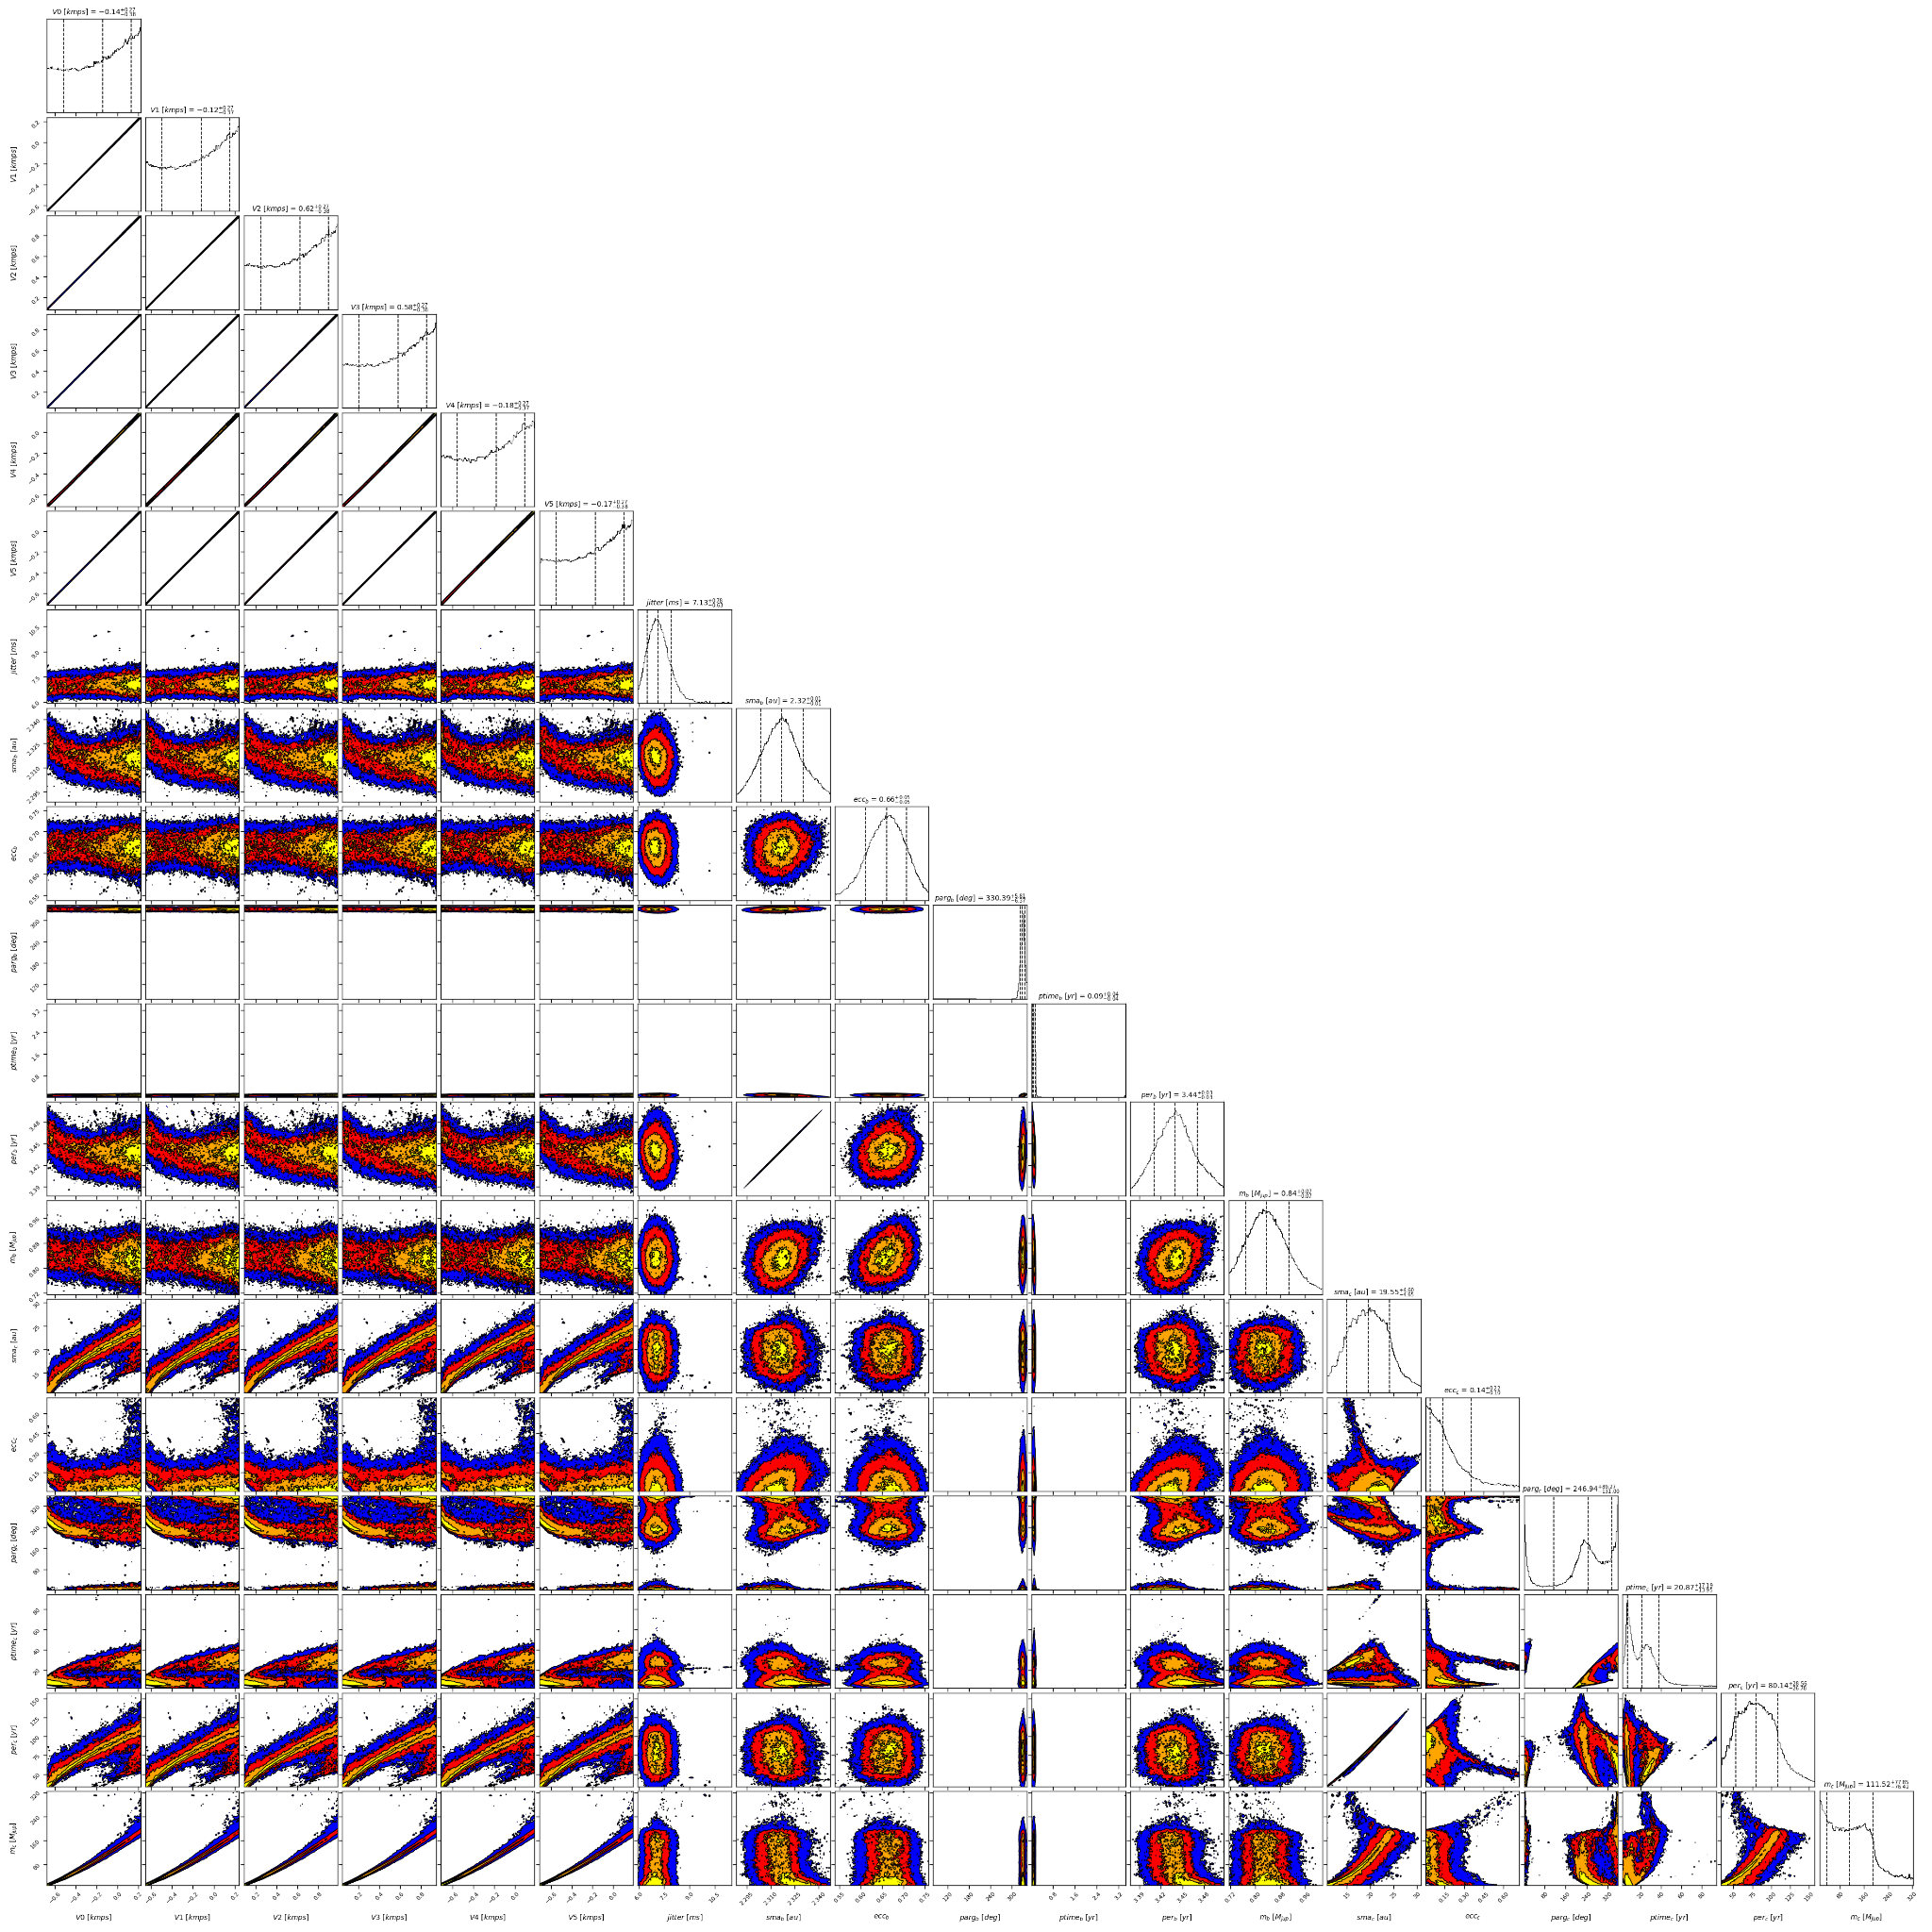

Figure 2: Corner plot of posteriors for the two-planets model MCMC fit of HD7449 RV data.

| Parameter | Priors | | | Posteriors | | | CHS |
| --- | --- | --- | --- | --- | --- | --- | --- |
|  | DPASS | | MCMC | DPASS | | MCMC |  |
|  | Free priors | Constrained offset | Free priors | Free priors | Constrained offset | Free priors |  |
| *a* (au) | b: [0,3]  c: [4,100] | b: [0,3]  c: [4,500] | b: [2,3]  c: [4,1000] | b = 2.3  c = 7.9 | b = 2.3  c = 25.3 | b =  c = 15 – 24 | b = 2.3  c = 5.1 |
| Msin(i) (MJup) | b: [0,10]  c: [0,1000] | b: [1,2]  c: [0,1000] | b: [0,10]  c: [1,1000] | b = 0.82  c = 6.4 | b = 1.2  c = 118 | b = 0.84 ± 0.07  c = 35 – 189 | b = 1.11  c = 2 |
| Eccentricity | b: [0,0.95]  c: [0,0.95] | b: [0.5,0.9]  c: [0,0.95] | b: [0,0.95]  c: [0,0.95] | b = 0.65  c = 0.23 | b = 0.79  c = 0.19 | b = 0.66 ± 0.05  c < 0.36 | b = 0.82  c = 0.53 |
| Instrumentals offsets (km/s) | [-60,60] | up to 0.6 | H03: [-20,-18]  H15: [-20,-18]  MIKE: [-1,1]  PFS: [-1,1]  C98: [-20,-18]  C07: [-20,-18] | H03: -19.7192  H15: -19.6810  MIKE: 0.00456  PFS: 0.0035  C98: -19.7560  C07: -19.7540 | 0.6 | H03: -19.518 – -18.867  H15: -19.497 – -18.850  MIKE: 0.246 – 0.898  PFS: 0.206 – 0.857  C98: -19.557 – -18.907  C07: -19.551 – -18.899 |  |
| Stellar jitter (m/s) | [0,40] | [0,40] | [0,20] | 6.4 | 7.3 |  |  |
| Argument of periastron (°) | b: [0,360]  c: [0,360] | b: [0,360]  c: [0,360] | b: [0,360]  c: [0,360] | b = 331  c = 343 | b = 330  c = 249 | b = 330 ± 6  c = 116 – 336 |  |
| Phase | b: [0,1]  c: [0,1] | b: [0,1]  c: [0,1] | b: [0,1]  c: [0,1] | b = 0.77  c = 0.29 | b = 0.47  c = 0.38 | b =  c = 0.08 – 0.53 |  |

Table 1: HD7449. Summary of priors and posteriors obtained with DPASS and MCMC, compared to the properties reported by the CH Survey.

References

1. Sousa, S. et al. Spectroscopic parameters for 451 stars in the HARPS GTO planet search program. Stellar [Fe/H] and the frequency of exo-Neptunes. *Astron. Astrophys*. 487, 373-381 (2008).
2. Wittenmyer, R. et al. Truly eccentric - I. Revisiting eight single-eccentric planetary systems. *Mon. Not. R. Astron. Soc.* 484, 5859-5867 (2019).
3. Rodigas, T. et al. MagAO Imaging of Long-period Objects (MILO). I. A Benchmark M Dwarf Companion Exciting a Massive Planet around the Sun-like Star HD7449. *Astrophys. J.* 818, 106 (2016).
4. Moutou, C. et al. Eccentricity in planetary systems and the role of binarity. Sample definition, initial results, and the system of HD211847. *Astron. Astrophys.* 602, A87 (2017).
5. Feng, F. et al. 3D Selection of 167 Substellar Companions to Nearby Stars. *Astrophys. J. Supp. Ser.* 262, 21 (2022).